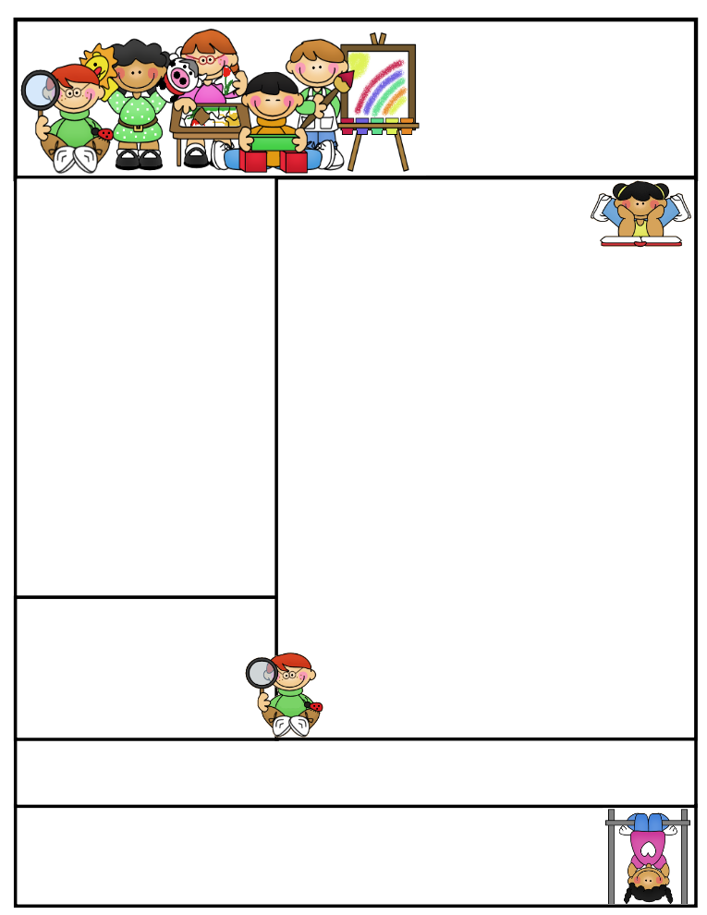

First Grade Newsletter

Story: **Soccer**

Name:

_________________________

Email: chorton@sharylandisd.org  
Conference: 2:30-3:15pm

Phone: 956-668-0426

**Note from teacher:** Students are responsible for completing homework and reading assignments every night. Homework is an opportunity to reinforce content learned that day in school. Student will be allowed to do homework during recess if not turned in.

**Reminders:**

* Weekly Tests on Friday
* AR goal due September 30, 2016
* Bring your own headphones
* Curriculum Night Tuesday at 5pm

No homework for child if parent attends meeting

What We’re Learning

**Story:** Soccer

**Skill**: Author’s Purpose

**Writing**: Personal Narrative

**Grammar:** Questions and Exclamations

**Math**: Five and Ten Relationships

**Science**: How do scientists work?

**S. Studies**: US Symbols

**Spelling Words:**

1. land
2. sand
3. fast
4. past
5. sink
6. wink
7. left
8. twist
9. very
10. use

**Homework: Read Daily!**

**Monday**

Rainbow Writing & SP19

**Tuesday**

ABC order & 41

**Wednesday**

Write a Sentence & 18

**Thursday**

Write a Pyramid & pg. SP18

**Behavior Report/ reporte de conducta**

Please Sign Daily/ favor de firmar diario

|  |
| --- |
| Teacher Comments:  Monday’s Signature:____________________________ |
| Teacher Comments:  Tuesday’s Signature:____________________________ |
| Teacher Comments:  Wednesday’s Signature:_________________________ |
| Teacher Comments:  Thursday’s Signature:___________________________ |
| Teacher Comments:  Friday Signature:_______________________________ |