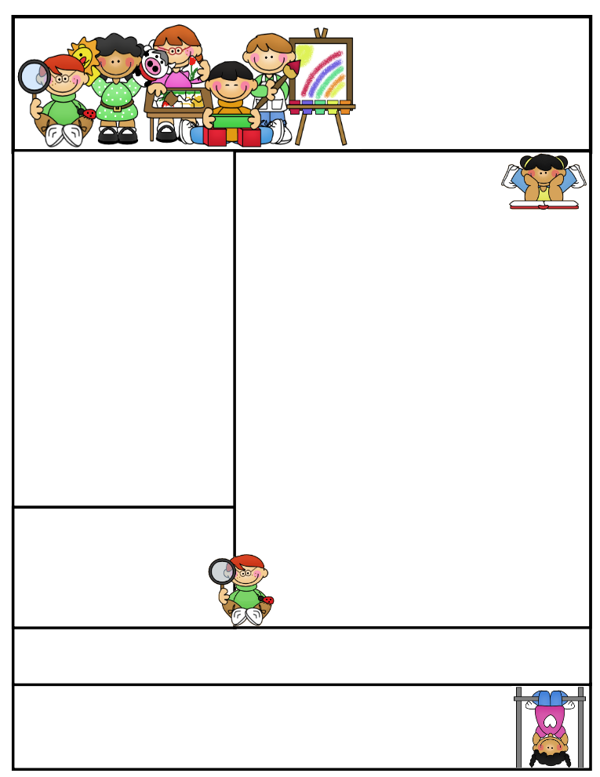

**Vocabulary**

**repetition rhyme alliteration**

**onomatopoeia lines stanza**

**rhythm theme image**

Reading Connection:

**Poetry: A writer sharing with the reader an experience or strong feelings.**.

**This Week’s Objectives:**

**Math** – Financial Literacy

**Science** – Food Chain

**Soc. Studies** – Good Citizen Responsibilities

**Reading** – Poetry

**Spelling –** Open and Closed Multisyllabic Words

**Grammar –** Conjunctions

**Writing –** Correspondence

**Important News**

In A.R., my students will be expected to test on two small books on a daily basis. Please remind your child to take all library books home to read and test the next morning.

**topic wagon**

**secret humor**

**music nickel**

**moment lizard**

**lemon pony**

**study fever**

**river visit**

**never driver**

**lady potato**

**fantastic hero**

Mrs. Morado’s

Newsletter

December 17, 2018

**Parents, please help your child be alert by getting them to bed and feeding them a healthy breakfast.**

**Don’t forget to study for your weekly exams!**

Work alone is noble.

Thomas Carlyle

Spelling Words

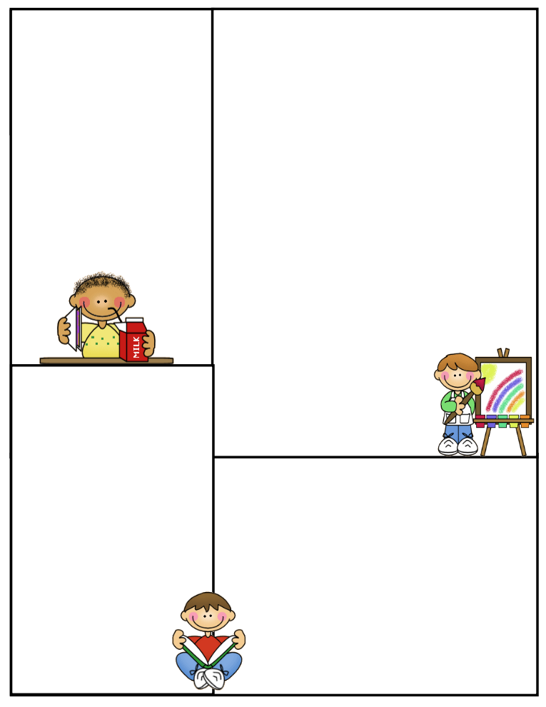

**What’s coming up:**

**Monday: No U.I.L.** / Dress like an Elf.

**Tuesday: No U.I.L.** / Wear Antlers and red noses

**Wednesday: No Tutoring /** Wear a Grinch shirt / Movie meal and a movie for $5

**Thursday:** Wear your pajamas

**Friday:** Wear something colorful or with lights / Christmas Party and Gift Exchange / **Today is** **Half a Day 12:30**

Important

**Spelling Test**: Fridays

**Math Test:** Fridays

**Reading Test**: Fridays

**Grammar Test**: Thursdays

**Science Test**: Thursdays

**Social Studies Test**: Thursdays

**Reading Comprehension**; Every two weeks on Thursdays

**Vocabulary**: Every two weeks on Thursdays

**Daily Homework:**

**Monday**

**Spelling –** ABC Order

**Reading –** Read A.R. Books

**Math –** Math Practice

**Tuesday**

**Spelling –** Triangular Spelling

**Reading –** Read A.R. Books

**Math –** Study for Math Test Tomorrow

**Wednesday**

**Spelling –** Study for test tomorrow

**Reading –** Read A.R. Books

**Math –** Study for End of 3rd Six Weeks Math Test

Tomorrow

**Thursday**

**No Homework**

**CLASS RULES**

1. **Listen when your teacher is talking**
2. **Follow directions quickly**
3. **Raise your hand to speak or to get out of your seat**
4. **Respect yourself, others, and your school**
5. **Pay attention and stay on task**