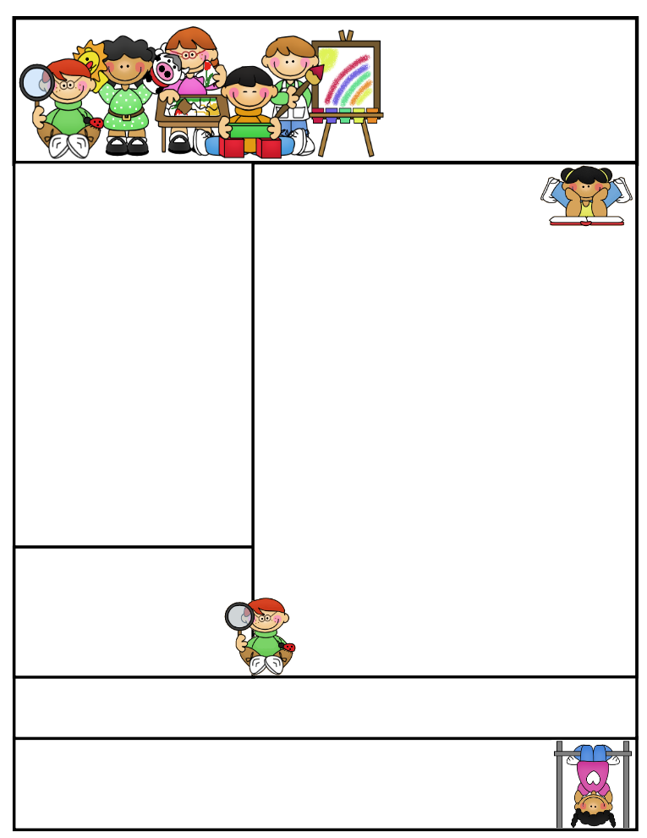

**Vocabulary**

**repetition rhyme alliteration**

**onomatopoeia lines stanza**

**rhythm theme image**

Reading Connection:

**Poetry: A writer sharing with the reader an experience or strong feelings.**.

**This Week’s Objectives:**

**Math** – Multiplication

**Science** – Food Chain

**Soc. Studies** – Good Citizen Responsibilities

**Reading** – Poetry

**Spelling –** Open and Closed Multisyllabic Words

**Grammar –** Conjunctions

**Writing –** Correspondence

**Important News**

In A.R., my students will be expected to test on two small books on a daily basis. Please remind your child to take all library books home to read and test the next morning.

**paper zipper**

**begin winter**

**bacon pocket**

**robot doctor**

**relax number**

**minus pumpkin**

**napkin earring**

**magnet catnip**

**bedbug carport**

**garden jacket**

Mrs. Morado’s

Newsletter

December 10, 2018

**Parents, please help your child be alert by getting them to bed and feeding them a healthy breakfast.**

**Don’t forget to study for your weekly exams!**

Work alone is noble.

Thomas Carlyle

Spelling Words

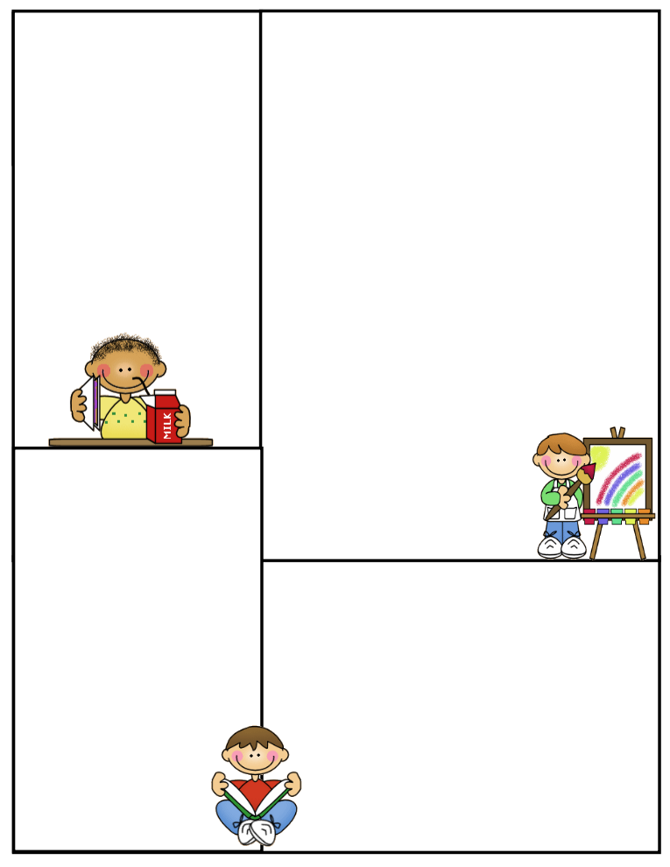

**What’s coming up:**

**Monday: U.I.L. Practice** /Wear Slippers

**Tuesday: U.I.L. Practice** /Wear Red and White

**Wednesday: Tutoring / Wear a scarf**

**Thursday: Wear a plaid or flannel shirt**

**Friday: Wear an ugly sweater**

**This Saturday, December 15 is our U.I.L. Meet at Shimotsu Elementary at 8:00A.M.**

**Please help us collect as many box tops as you can to help our school.**

Important

**Spelling Test**: Fridays

**Math Test:** Fridays

**Reading Test**: Fridays

**Grammar Test**: Thursdays

**Science Test**: Thursdays

**Social Studies Test**: Thursdays

**Reading Comprehension**; Every two weeks on Thursdays

**Vocabulary**: Every two weeks on Thursdays

**Daily Homework:**

**Monday**

**Spelling –** ABC Order

**Reading –** Read A.R. Books

**Math –** Math Practice

**Tuesday**

**Spelling –** Triangular Spelling

**Reading –** Read A.R. Books

**Math –** Math Practice

**Wednesday**

**Spelling –** Ten sentences with 10 spelling words

**Reading –** Read A.R. Books

**Math –** Math Practice

**Thursday**

**Spelling –** Study for test tomorrow

**Reading –** Read A.R. Books

**Math –** Math Practice

**CLASS RULES**

1. **Listen when your teacher is talking**
2. **Follow directions quickly**
3. **Raise your hand to speak or to get out of your seat**
4. **Respect yourself, others, and your school**
5. **Pay attention and stay on task**