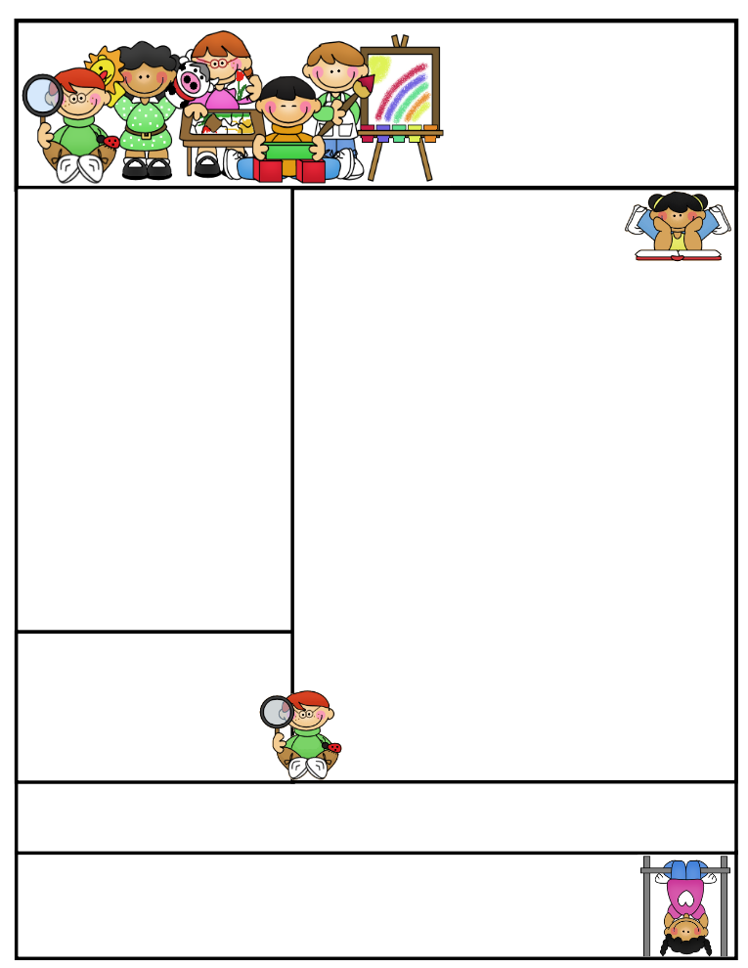

**Vocabulary**

**tundra Arctic temperature**

**climate livable**

**This Week’s Objectives:**

**Math** – Reviewing Adding Three Digit

Numbers with Two-Digit Numbers

**Science** – Force and Motion

**Soc. Studies** – Culture

**Reading** – Nonfiction / Informational Text

“The Arctic Tundra”

**Spelling –** Compound Words

**Grammar –** Present, Past, and Future Tense Verbs

**Writing –** Expository / Informative

**Important News**

* We will be taking the **Math and Reading Benchmarks** **#2** this week. Please talk to your kids about the importance of these assessments.

**Parents, please help your child be alert by getting them early to bed and feeding them a healthy breakfast.**

**Don’t forget to study for your weekly exams!**

Reading Connection:

**Informational Text: tells facts and details about a main or central idea.**

**sunflower weekend**

**notebook backyard**

**himself bathtub**

**baseball basketball**

**inside snowman**

**cookbook superman**

**flowerpot waterfall**

**sunburn doghouse**

**ladybug starfish**

**raindrop mailbox**

Mrs. Morado’s

Newsletter

November 4, 2019

, 2019

Work alone is noble.

Thomas Carlyle

Spelling Words

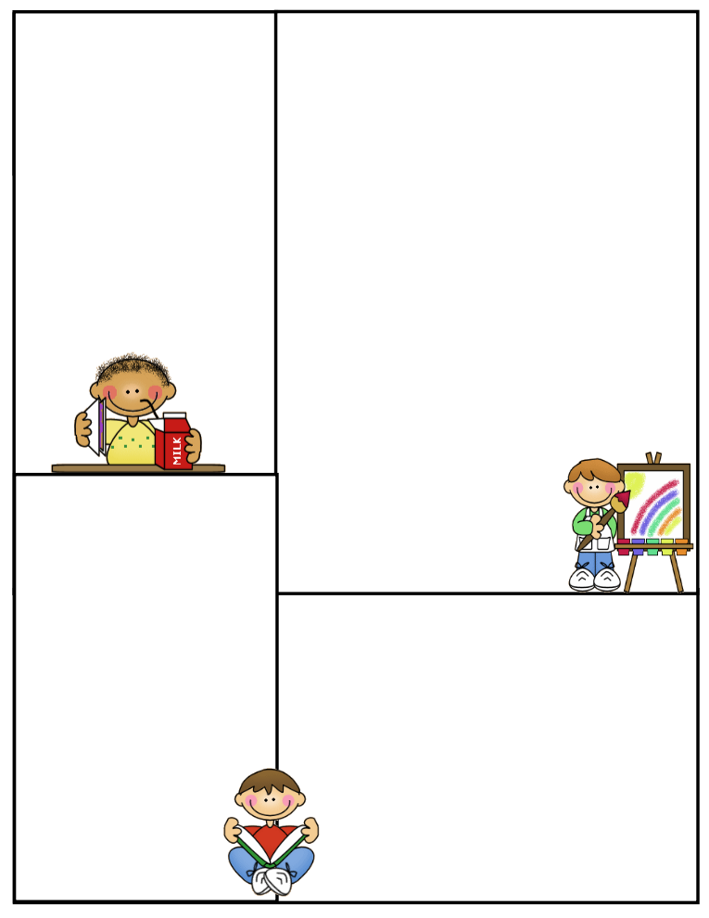

Important

**Spelling Test**: Fridays

**Math Test:** Fridays

**Reading Test**: Fridays

**Grammar Test**: Fridays

**Science Test**: Thursdays

**Social Studies Test**: Thursdays

**Reading Comprehension**;:Fridays

**What’s coming up:**

***Monday 4 -* U.I.L. Practice from 3:30-4:15 Math Benchmark #2**

***Tuesday 5* – U.I.L. Practice from 3:30-4:15.**

***Thursday 7* – Reading Benchmark #2**

**Daily Homework:**

**Monday**

**Spelling –** ABC order.

**Math–** Math Worksheet

**Reading -** Study vocabulary words

**Tuesday**

**Spelling –** Triangular Spelling

**Math –** Math Worksheet

**Reading -** Study vocabulary words

**Wednesday**

**Spelling –** Ten sentences with 10 spelling words

**Math –** Math Worksheet

**Reading -** Study vocabulary words

**Thursday**

**Spelling –** Study for test tomorrow

**Math –** Math Worksheet

**Reading -** Study vocabulary words

**Spelling Homework *will always be***

***done in the Spelling Spiral.***

**CLASS RULES**

1. **Listen when your teacher is talking**
2. **Follow directions quickly**
3. **Raise your hand to speak or to get out of your seat**
4. **Respect yourself, others, and your school**
5. **Pay attention and stay on task**