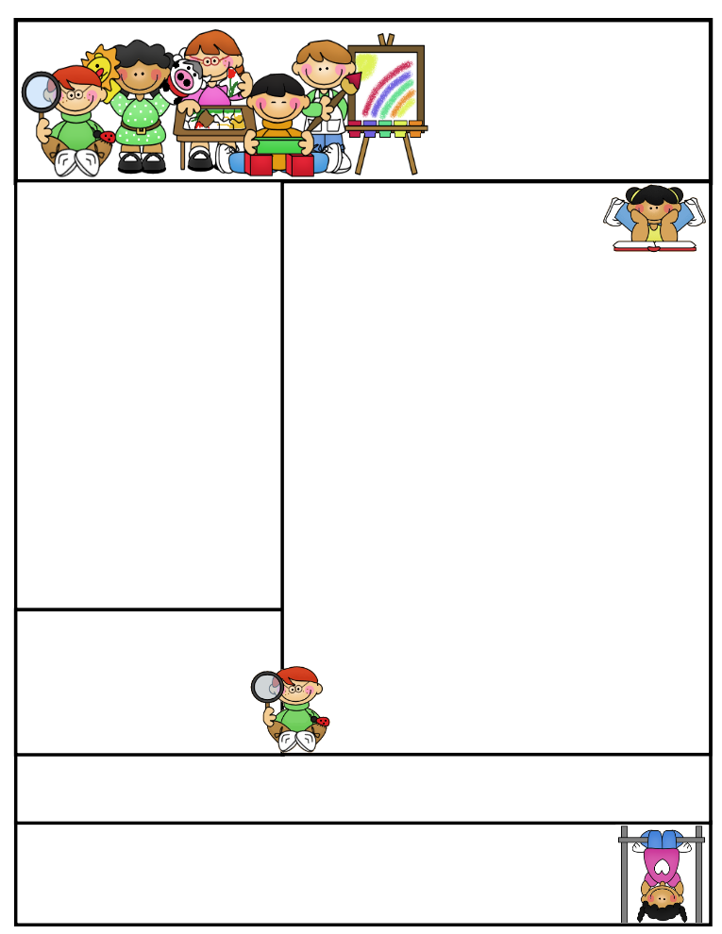

**Parents, please help your child be alert by getting them early to bed and feeding them a healthy breakfast.**

**Don’t forget to study for your weekly exams!**

**Vocabulary**

**oval waddle huddle**

**penguin flock**

Reading Connection:

**Fiction: a story that did not really happen. In a fiction story there are made up events, setting, and characters.**

**This Week’s Objectives:**

**Math** – Comparing Whole Numbers

**Science** – Properties of Matter

**Soc. Studies** – Geography

**Reading** – Fiction

“What’s In the Egg, Little Pip?”

**Spelling –** Consonant Blend Words

**Grammar –** Pronouns

**Writing –** Narrative / Why Do Animals Protect Their

Babies?

**Important News**

* I will *always* assign spelling and math homework except on Fridays.
* In A.R., my students will be expected to test on two small books on a daily basis. Please remind your child to take all library books home to read and test the next morning.

**each team**

**street key**

**read feel**

**deep party**

**easy beach**

**clean bread**

**tree green**

**great treat**

**meal heat**

**meat head**

Mrs. Morado’s

Newsletter

September 9, 2019

, 2019

Work alone is noble.

Thomas Carlyle

Spelling Words

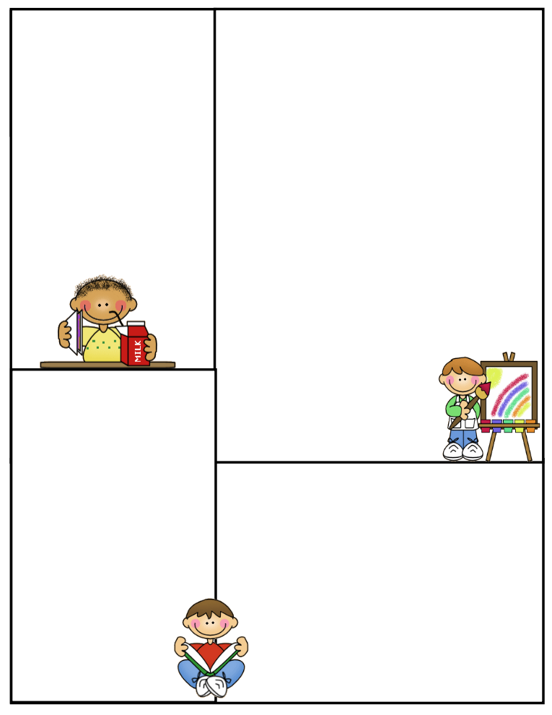

**Spelling Homework *will always be***

***done in the Spelling Spiral.***

**What’s coming up:**

**U.I.L. Try Outs will be on September 16-17 at 3:30-4:15**

**Please check your child’s Red Conduct Folder on a daily basis. Parent signature is required every Friday.**

**One point will be taken off when no homework is turned in. After three occurrences, recess will be taken away. Please talk to your child.**

**Students may bring a small nutritional snack to class.**

**P**

Important

**Spelling Test**: Fridays

**Math Test:** Fridays

**Reading Test**: Fridays

**Grammar Test**: Thursdays

**Science Test**: Thursdays

**Social Studies Test**: Thursdays

**Reading Comprehension**; Every two weeks on Thursdays

**Daily Homework:**

**Monday**

**Spelling –** ABC order.

**Math–** Math Worksheet

**Tuesday**

**Spelling –** Triangular Spelling

**Math –** Math Worksheet

**Wednesday**

**Spelling –** Ten sentences with 10 spelling words

**Math –** Math Worksheet

**Thursday**

**Spelling –** Study for test tomorrow

**Math –** Math Worksheet

**CLASS RULES**

1. **Listen when your teacher is talking**
2. **Follow directions quickly**
3. **Raise your hand to speak or to get out of your seat**
4. **Respect yourself, others, and your school**
5. **Pay attention and stay on task**