5th Grade Homework/Newsletter
December 11-15, 2017
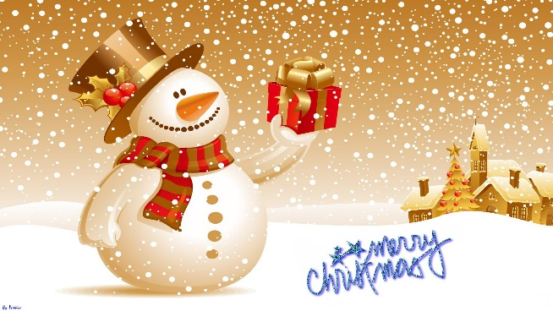
*U.I.L. and tutoring is Monday-Tuesday ONLY. Buses will be available Monday-Tuesday.
*My Calendar on my webpage has all the events for this month!
*Please make sure your children are reading their library books each day. It is important they meet their A.R. goals.
Progress Reports Go Out- Please sign and return.
Landform Christmas Ornaments are DUE MONDAY, DECEMBER 11, 2017!!
Monday- Wear Comfy Slippers
- Reading Passage- “Myreel’s Moment”
- Spelling Tic Tac Toe
- Math- Review 13
- Study Science Vocabulary (Fossil Fuels / Sedimentary Rocks)
(Read library books, be ready to test!)
Tuesday- Wear a Grinch Shirt
- Reading Passage- “Opening Up”
- Spelling Tic Tac Toe
- Math- Review 14
- Study Science Vocabulary (Fossil Fuels / Sedimentary Rocks
(Read library books, be ready to test!)
Wednesday- Dress up like an Elf!!!
- Reading Passage- “The Bull Ride”
- Spelling Tic Tac Toe
- Math- Review 15 and 16
- Study Science Vocabulary (Fossil Fuels / Sedimentary Rocks
(Read library books, be ready to test!)
Thursday- Wear Candy Cane colors Red and White
- Reading Passage- “First Aid Friendship”
- Spelling Pretest
- Math- Review 17 through 20
- Study Science Vocabulary (Fossil Fuels / Sedimentary Rocks TEST TOMORROW!
(Read library books, be ready to test!)
Friday- Wear an Ugly Sweater!!!!
Friday-Sunday-Reading library books, be ready to test!

