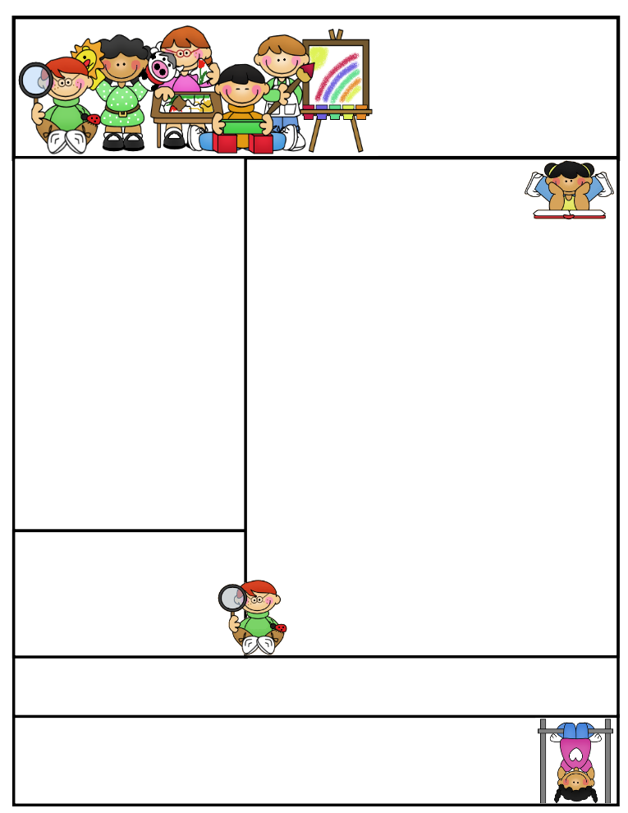

**Vocabulary**

**Chronological Order Time Line**

**Cause and Effect Biography**

**Persuasive Central Idea Autobiography**

Reading Connection:

**Biography: A person’s life story told by someone else.**

**This Week’s Objectives:**

**Math** – Number Line

**Science** – Magnets

**Soc. Studies** – Important People

**Reading** – Biographies

**Spelling –** VCE Words

**Grammar –** Contractions

**Writing –** Informational Composition

**Important News**

In A.R., my students will be expected to test on two small books on a daily basis. Please remind your child to take all library books home to read and test the next morning.

**translate escape**

**confuse shameful**

**mistake invite**

**inside inflate**

**explore complete**

**athlete advice**

**explode excuse**

**complete dislike**

**upgrade incline**

**tadpole ignore**

Mrs. Morado’s

Newsletter

March 25, 2019

**Parents, please help your child be alert by getting them to bed and feeding them a healthy breakfast.**

**Don’t forget to study for your weekly exams!**

Work alone is noble.

Thomas Carlyle

Spelling Words

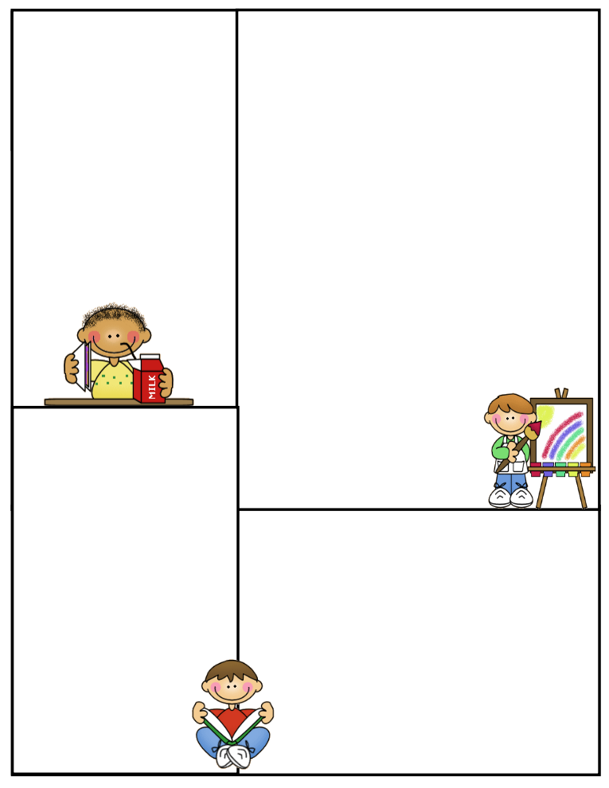

**What’s coming up:**

**Monday: Tutoring**

**Tuesday: Tutoring**

**Wednesday: Tutoring**

**Saturday, March 30: Saturday Tutoring**

**From 8:30 to 11:00A.M.**

Important

**Spelling Test**: Fridays

**Math Test:** Fridays

**Reading Test**: Fridays

**Grammar Test**: Thursdays

**Science Test**: Thursdays

**Social Studies Test**: Thursdays

**Reading Comprehension**; Every two weeks on Thursdays

**Vocabulary**: Every two weeks on Thursdays

**Daily Homework:**

**Monday**

**Spelling –** ABC Order

**Reading –** Read A.R. Books

**Math –** Math Practice

**Tuesday**

**Spelling –** Triangular Spelling

**Reading –** Read A.R. Books

**Math –** Math Practice

**Wednesday**

**Spelling –** Ten sentences with 10 spelling words

**Reading –** Read A.R. Books

**Math –** Math Practice

**Thursday**

**Spelling –** Study for test tomorrow

**Reading –** Read A.R. Books

**Math –** Math Practice

**CLASS RULES**

1. **Listen when your teacher is talking**
2. **Follow directions quickly**
3. **Raise your hand to speak or to get out of your seat**
4. **Respect yourself, others, and your school**
5. **Pay attention and stay on task**