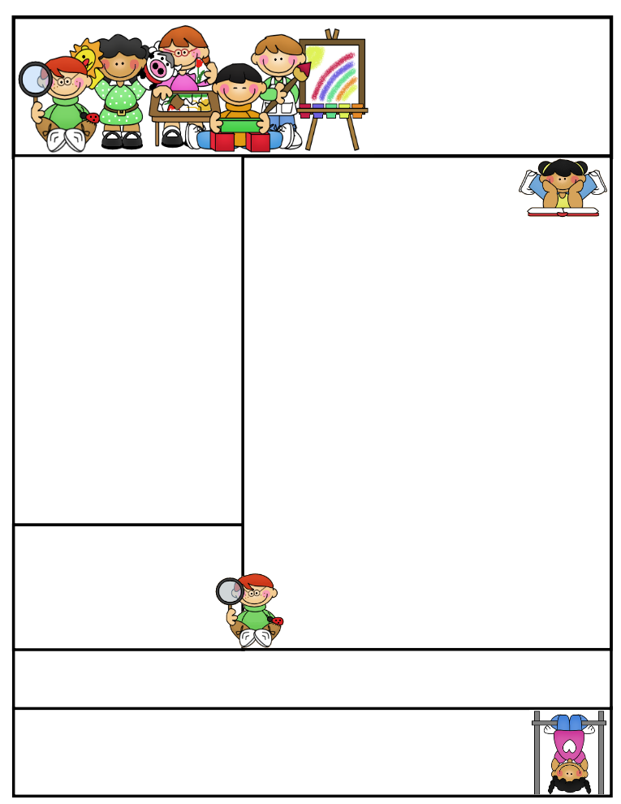

**Vocabulary**

**assembled devoured fetch**

**menu simmered**

**This Week’s Objectives:**

**Math** –Yearly Objectives Review

**Science** – Animals and Plants

**Soc. Studies** – Technology Then and Now

**Reading** – Story Structure

**Spelling –** Words with consonant a, au, and aw

**Grammar –** Contractions/Apostrophes

**Writing –** Making a Descriptive Flyer

**Important News**

**May 16 will be the last day to A.R. Please help your child by reminding him/her to read to meet their reading goal.**

**yawn hawk**

**auto straw**

**fault awful**

**sauce draw**

**jaw walk**

**claw paw**

**August cause**

**laundry author**

**because salt**

**law saw**

Mrs. Morado’s

Newsletter

May 14, 2018

**Parents, please help your child be alert by getting them to bed and feeding them a healthy breakfast.**

**Don’t forget to study for your weekly exams!**

Work alone is noble.

Thomas Carlyle

Reading Connection:

**Story Stucture** – A story’s beginning, middle, and end.

Spelling Words

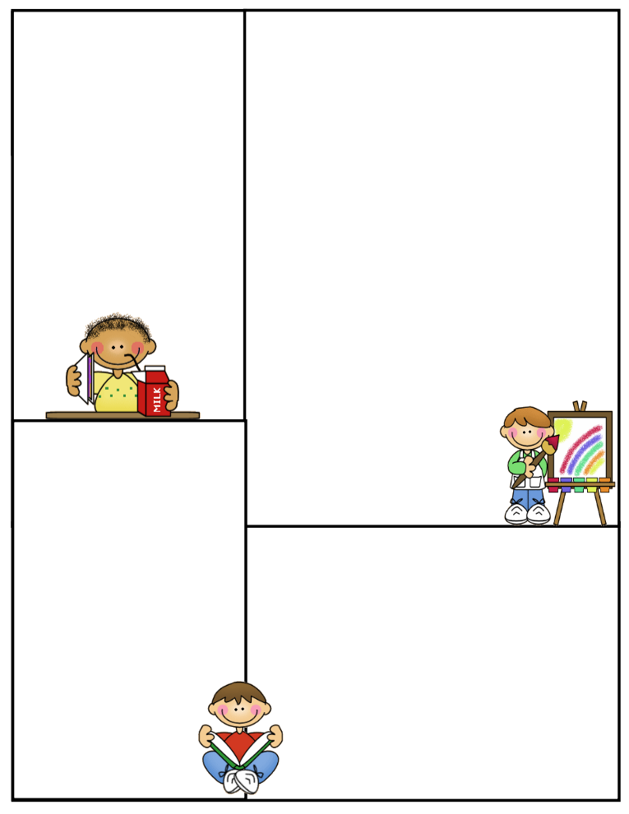

**What’s coming up:**

**There will be no more tutoring for the rest of the year.**

Important

**Spelling Test**: Fridays

**Math Test:** Fridays

**Reading Test**: Fridays

**Grammar Test**: Thursdays

**Science Test**: Thursdays

**Social Studies Test**: Thursdays

**Reading Comprehension**; Every two weeks on Thursdays

**Vocabulary**: Every two weeks on Thursdays

**Daily Homework:**

**Monday**

**Spelling -** Write a sentence with 10 spelling word.

**Reading –** Read A.R. Books

**Math –** Math Practice Sheet

**Tuesday**

**Spelling**- Pyramid spelling

**Reading –** Read A.R. Books

**Math –** Math Practice Sheet

**Wednesday**

**Spelling-** ABC order

**Reading –** Read A.R. Books

**Math –** Math Practice Sheet

**Thursday**

**Spelling-** Study for test

**Math –**Math Practice Sheet

**CLASS RULES**

1. **Listen when your teacher is talking**
2. **Follow directions quickly**
3. **Raise your hand to speak or to get out of your seat**
4. **Respect yourself, others, and your school**
5. **Pay attention and stay on task**